San Jose State University

EE250 (Section 2) Fall 2019 Prof. Kamali

Solution to Problem Set #10

- Problem 9.65
a)
The only way that 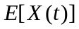 does not depend on is that 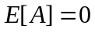 (which implies 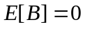because and have identical distribution.) in which case 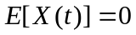

Since and are independent with zero mean 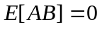. Furthermore since and have identical distribution, 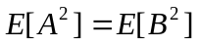. Thus

Therefore under the condition , 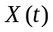is WSS.

b) 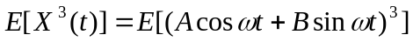
We note that 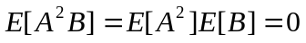and 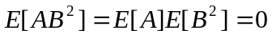. Furthermore 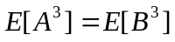and thus

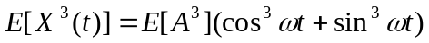

Clearly 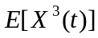 changes by and thus is not stationary.

- [Final Exam, Spring 2007] Suppose 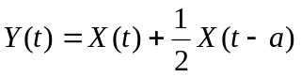 whereis a wide sense stationary process with zero mean and auto-covariance function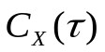.

- Find 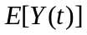and 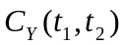.
- Is 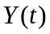wide sense stationary?

Solution:
a) 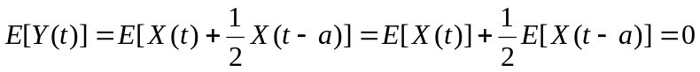

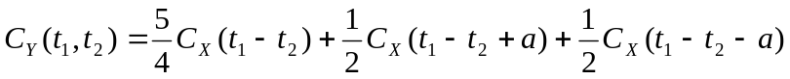

b) Since 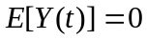 and only depends on 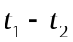, is wide sense stationary.

- [Final Exam, Spring 2008] Suppose 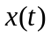is a zero mean stationary random process with auto-correlation function
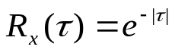

and 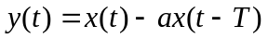where 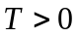.

- Find the auto-correlation function of 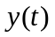.
- Find to minimize 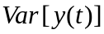.

Solution:
a)
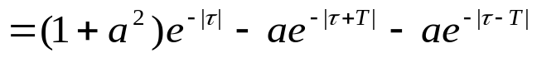

b)

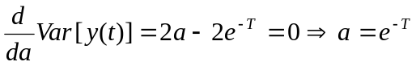

- [Final Exam, Fall 2014] Consider the random process 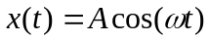, whereis a zero mean and unit variance Gaussian random variable.

- Find the mean and auto-covariance of 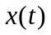.
- Is stationary?

Solution:

a)

where we have used 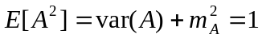.

b) No, Since auto-covariance is not a function of 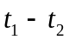only, is not stationary.

- [Final Exam, Spring 2015] Consider the random process 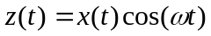 whereis a zero mean stationary process with the auto-correlation 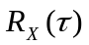.

- Find 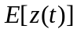 and 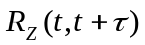.
- Is 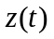stationary?

Solution:

a) 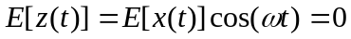

b) No, Since auto-covariance is not a function of only, is not stationary.

- [Final Exam, Fall 2014] Suppose is a random process which starts at time 0 at 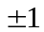with equal probability (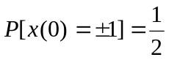) and goes up by one every time a Poisson event takes place. The Poisson events happen with the rate of 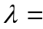1 event/second. Find 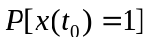for 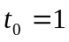.

Solution:

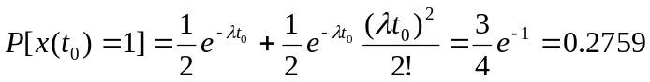

7. [Final Exam, Fall 2014] Consider the process 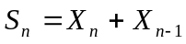 where 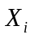's are iid and 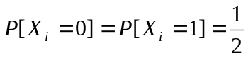.
a) Find the pmf of .
b) Find the joint pmf of and 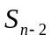.
c) Find the joint pmf of and 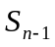.

Solution:
- Given that 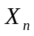and 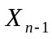are independent, we have
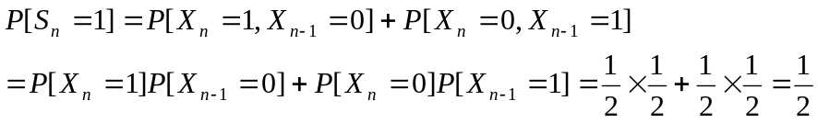
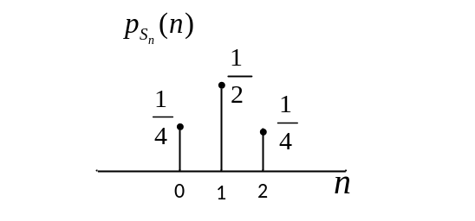
- Since 's are iid, and 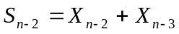are independent and thus

The joint pmf will then be as follows.

 | 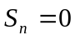 | 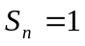 | 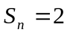
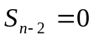 | 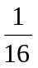
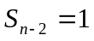 |  | 
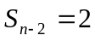

- Clearly and 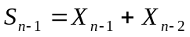are not independent.

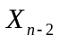 |  | 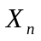
0 | 0 | 0 | 0 | 0
0 | 0 | 1 | 0 | 1
0 | 1 | 0 | 1 | 1
0 | 1 | 1 | 1 | 2
1 | 0 | 0 | 1 | 0
1 | 0 | 1 | 1 | 1
1 | 1 | 0 | 2 | 1
1 | 1 | 1 | 2 | 2

The joint pmf will then be as follows.

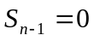
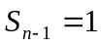
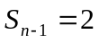

- [Final, Fall 2014] Consider the random process , whereis a zero mean and unit variance Gaussian random variable.

- Find the mean and auto-covariance of .
- Is stationary?

Solution:

a)

where we have used .

b) No, Since auto-covariance is not a function of only, is not stationary.

